**Working with Arduino**

**Overview**

Arduino is an open source hardware and software project, created with a simple aim in mind, to be as simple as possible. Arduino is not some piece of hardware you should be afraid of. Arduino comes in a variety of flavors and sizes. It is used by artists, hackers, hobbyists, and professionals to easily design, prototype and experiment with electronics. Use it as brains for your robot, to build a new digital music instrument, or to make your house plant tweet you when it's dry. An Arduino contains a microchip, which is a very small computer that you can program. You can attach sensors to it so that it can measure conditions (like how much light there is in the room). It can control how other objects react to those conditions (room gets dark. LED turns on).

| **Name** | **Processor** | | **Host** |  | | | | **I/O (pins)** | | |
| --- | --- | --- | --- | --- | --- | --- | --- | --- | --- | --- |
|  | Processor | Frequency |  | Voltage | Flash  (kB) | EEPROM  (kB) | SRAM  (kB) | Digital | Digital with  PWM | Analog |
| Arduino Uno | ATMega328P | 16 MHz | USB | 5V | 32 | 1 | 2 | 14 | 6 | 6 |

**Arduino Programming Environment**

We will be using the Arduino IDE to program our Arduino. Your computer may have an installed version of the Arduino IDE or you could have a standalone version. I have installed the Arduino IDE and you can start it from the Start Menu.

The Arduino Integrated Development Environment - or Arduino Software (IDE) - contains a text editor for writing code, a message area, a text console, a toolbar with buttons for common functions and a series of menus. It connects to the Arduino and Genuino hardware to upload programs and communicate with them.

Programs written using Arduino Software (IDE) are called sketches. These sketches are written in the text editor and are saved with the file extension .ino. The editor has features for cutting/pasting and for searching/replacing text. The message area gives feedback while saving and exporting and also displays errors. The console displays text output by the Arduino Software (IDE), including complete error messages and other information. The bottom righthand corner of the window displays the configured board and serial port. The toolbar buttons allow you to verify and upload programs, create, open, and save sketches, and open the serial monitor.

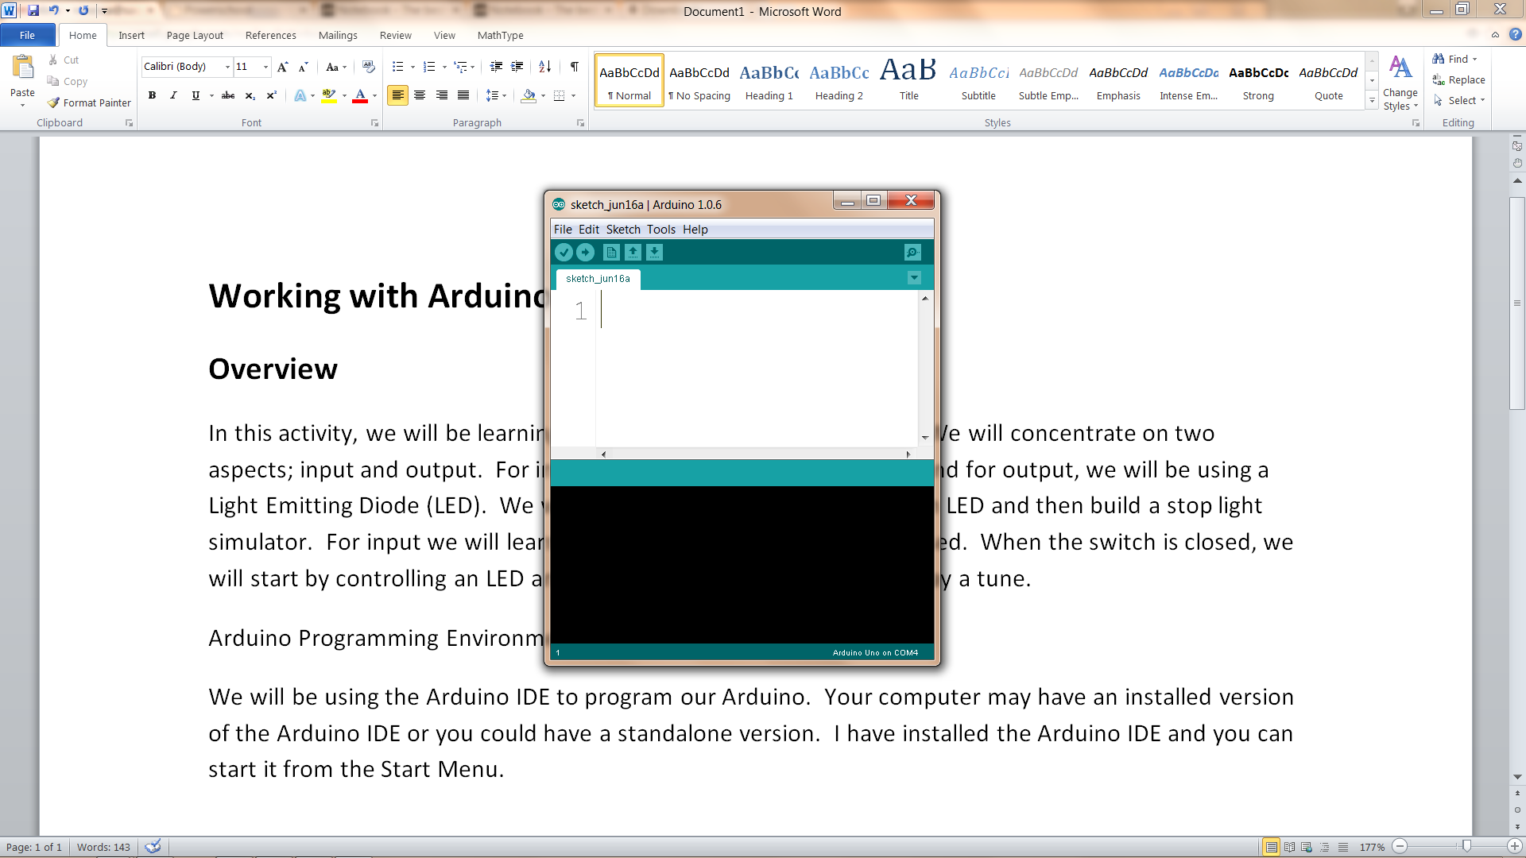

Upload/Run

Compile Button

Communication Port

With your Arduino hooked up with the USB A-B cable there are a couple of things you need to make sure are setup correctly.

The board should be selected to Arduino Uno. You can check this from the Tools|Board menu.

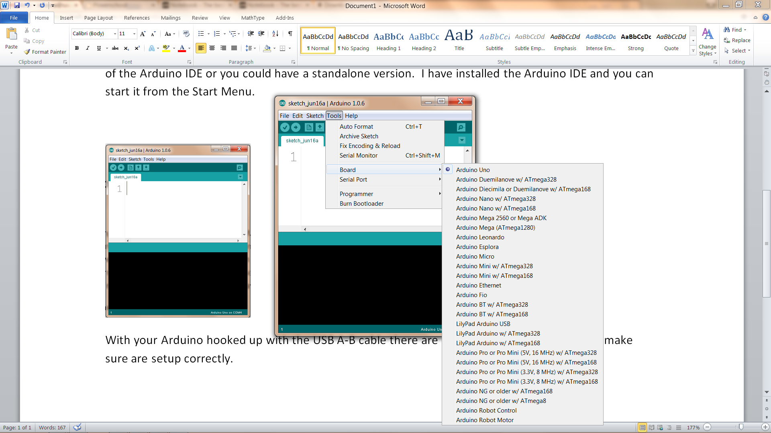

You will want to check the serial port connected. This can be done via the Tools|Serial Port manu.

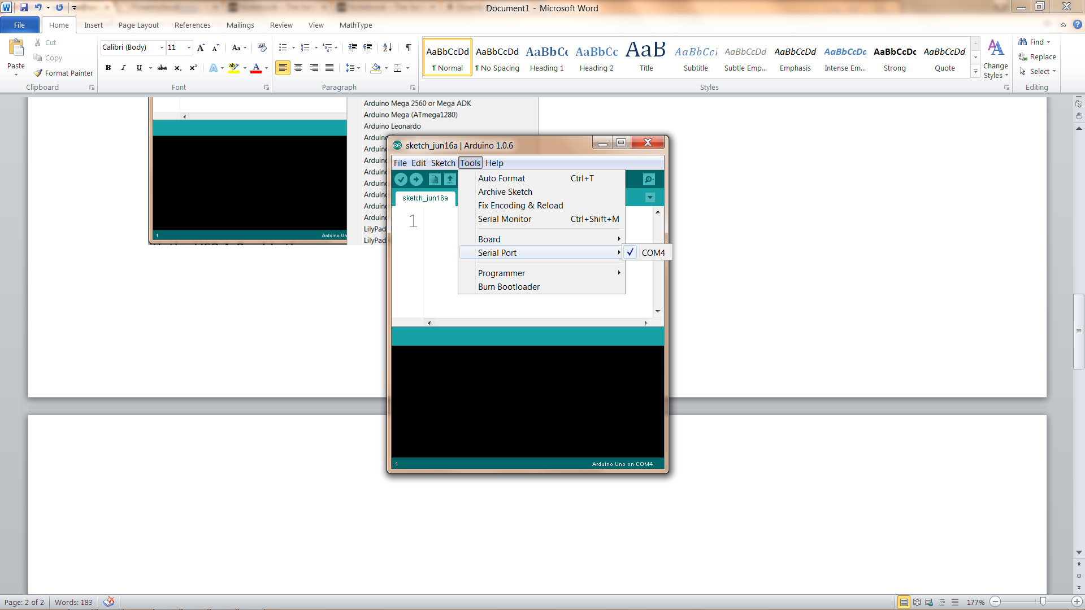

**Running your first program (Blink)**

With the Arduino IDE running, open up the example blink.

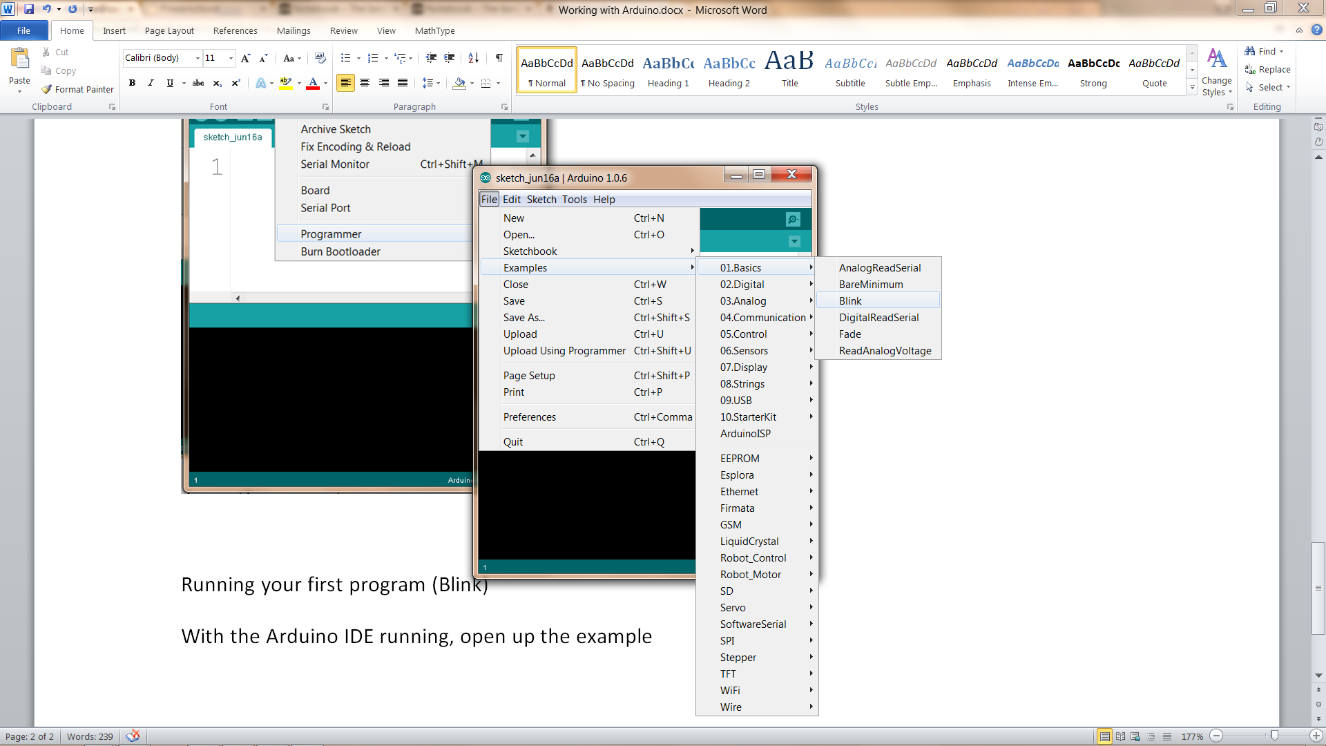

Now compile blink (turn the source code into 1s and 0s) by clicking on the checkmark in the toolbar.

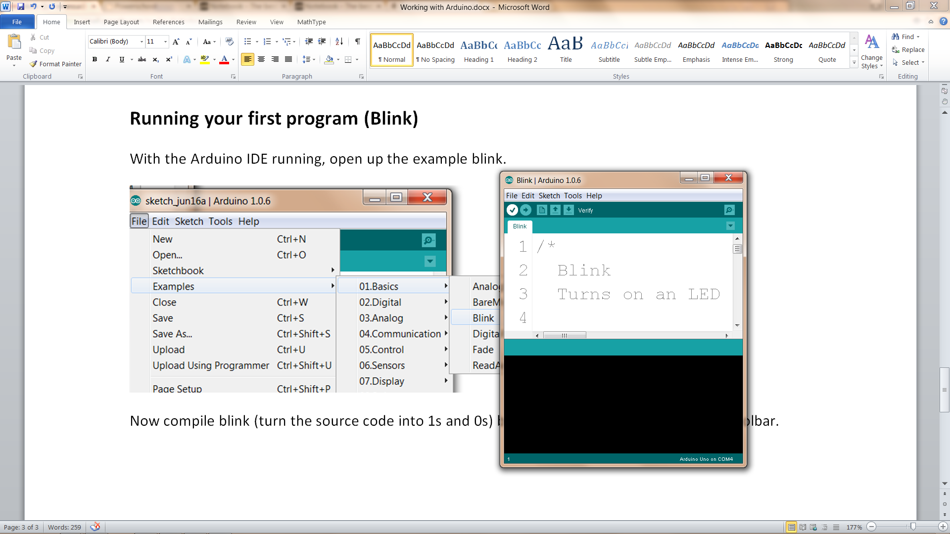

Now upload your executable program to the Arduino by clicking on the right arrow in the toolbar.

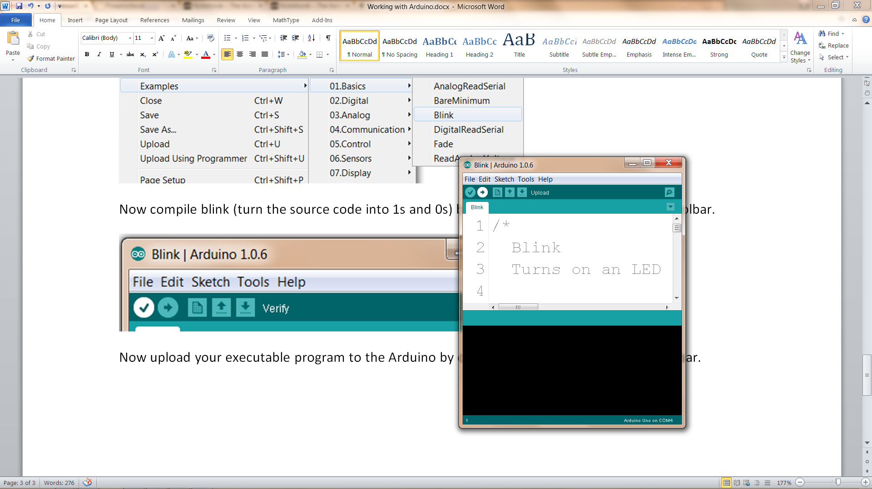

You should now see the pin 13 LED blink every second.